H M S Providence
2nd Minesweeper Flotilla, C-in-C Mediterranean
Vice-Admiral Sir Cecil Harcourt, KCB, CBE, Royal Navy

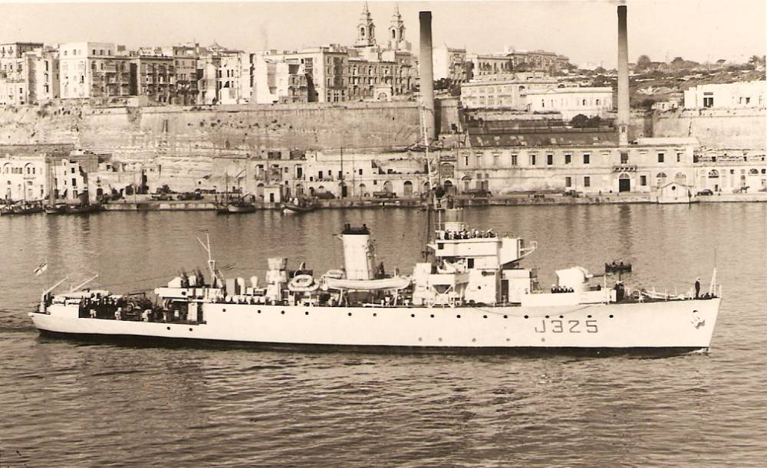

HMS Providence, at Malta, October 1946

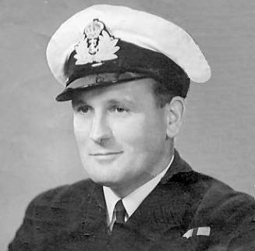
Lieutenant William E Messinger, Royal Navy, Commanding Officer

My Father’s Story……..

Some years ago I set up a website in order to tell the story of an incident involving my late father, Commander William E Messinger OBE, RN, who commanded a ship on the Royal Navy’s Palestine Patrol shortly after the end of the war. My Father was born at Upton-Upon-Severn, in Worcestershire on 31st May 1912, and joined the Royal Navy as a Signal Boy, on 21st August 1928 at sixteen years of age. He is the first man ever to have risen through the ranks of the RN, from Signal Boy, to Commander, and to have commanded one of Her Majesty’s warships. During the course of his Naval service, he was awarded both the MBE and OBE, retiring on 31st May 1962, after 34 years continuous service. During the war he served in HMS Renown and the mighty Ark Royal, seeing action in the sinking of the Bismarck and on Malta convoys. Commissioned Lieutenant on the 18th April 1943, he was Officer-In-Charge of tactical communications for the Allied landings at Salerno, the invasion of mainland Italy, under the guns of the Nazis 16th Panzer Division, on 9th September. I was born on the 21st - it took several days for the news of my safe arrival to reach my Father in the command ship Hilary, a requisitioned Bibby Liner!

Dad was very deeply touched by the plight of the Jewish people and I think the Palestine Patrol, intercepting immigrant ships from mainland Europe, laden to the gunwales with the survivors of the Nazi Holocaust, was a very difficult time for him. He was an intensely religious man and a great humanitarian. After six years at sea, spent fighting the Nazis, followed by an all too short leave at home with my Mother Doris and I - and new arrival Phillip, he was given orders to take command of HMS Providence, a large Algerine Class Fleet Minesweeper, and to proceed to Palestine with the utmost despatch. Sustained by the Zionist dream of a homeland, 125,000 Jewish men, women and children made the perilous journey by sea to Palestine, during the period to 1948 - despite the many obstacles placed in their way by the adamant opposition of the British government. Homeless refugees, survivors of a pitiless Nazi extermination policy, heading for the one place that promised them hope and a future. I am sure that my Father, and his ship’s company found their three years intercepting, arresting and detaining these people, a very difficult task indeed.
Admiral Sir Nigel Essenhigh, KCB, ADC,RN – First Sea Lord, writing in 2002, described the situation thus:
In the aftermath of the Second World War, no task that fell to the Royal Navy was more demanding than the interception of sea-borne illegal immigration into Palestine between 1945 and 1948. The Royal Navy’s Palestine Patrol undertook this operation in close co-operation with the Royal Air Force. Skilled ship handling was essential and boarding parties faced considerable hazards. The human factor was, as ever, vital to the success of the patrol; many of those involved onboard the Navy’s ships were wartime personnel, looking forward to speedy demobilization. In these circumstances, the efficiency and determination that were shown are all the more praiseworthy. Nelson prayed for humanity in his Fleet and this quality was well demonstrated time and again. The Royal Navy’s well executed and successful contribution helped towards the best solution that could be found at the time, and maintained the Navy’s high standing and unique reputation.

Many servicemen were ‘mentioned in despatches’, recommended for medals and decorations, but none were ever awarded - such was the intransigence of the British Government of the day. The continuation of shiploads of Holocaust survivors, arriving in Palestine under the guns of the Royal Navy, eventually broke down the British Government’s resistance, and in 1948 the British Mandate in Palestine was terminated.

Jewish survivors of the Nazi Holocaust, mainly from Poland, travelling by night in horse-drawn vehicles for anything from two to five months, arrived exhausted at the Yugoslavian port of Bakar. Commandeered by six agents of the Israeli Mossad, the motor ship Athina, built in 1897 for G T Soley & Company of Greenock, was loading humanitarian food supplies from the UN’s Relief and Rehabilitation Administration, and just enough fuel oil to get her to Palestine. The Zionist flag was hoisted and the ship's name changed to Rafiah, after members of the Haganah, who had been apprehended by the British and deported to a prison camp in the Egyptian town of Rafiah in Northern Sinai. With eight hundred refugees, men, women and children embarked, she headed south on 26th November 1946, through the Strait of Otranto and into the Ionian Sea. Rounding the southern tip of Peloponnisos, to the north of Crete, the ship arrived off Sirna Island in the Dodecanese on the 7th December. Here she was scheduled to meet a boat that would take off some of the ship's foreign crew. But it was no where to be seen. But it was nowhere to be seen. The captain decided to enter a large gulf in the island, which was not well-protected, and anchor there until the storm was over. The captain decided to enter a large bay, which was not well-protected, intending to shelter there until the storm had abated. While attempting to anchor, the "Rafah" got hit by rocks and water began to penetrate it.While attempting to anchor, the Athina /Rafiah ran onto rocks and began to take on water at an alarming rate. The immigrants jumped overboard and climbed to the shore using ropes.The terrified immigrants, men, women and children, were ordered to jump overboard in the darkness. Some managed to clamber ashore with the help of hastily rigged ropes. Others had to jump into the sea. Babies were wrapped in bundles and tossed to those in the water below. Within forty-five minutes, 45 minutes later, the ship sunk.the ship had sunk. Eight immigrants died in the tragedy: Yosef Greenberg (14); Peppy Weisberg (16); Tsili Yankowitz (22); Nachum David Futterman (28); Dora Katz (28); Shelly (last name unknown – 14); Etti (last name and age unknown) and another immigrant who was not identified.Eight immigrants died in the tragedy, their bodies washing ashore on the morning tide. As one of the survivors, a child at the time wrote: It is hard to describe the panic and shock at that moment: 800 souls in a leaking tub desperately trying to save their lives, under the worst weather conditions possible, in the freezing cold, with 6-7 meter waves, clothed only in their underwear or robes jumping onto the rocks and into the raging waters.

Late on the 8th December, an RAF reconnaissance aircraft from Cyprus, alerted by radio, was tasked to sweep the area and drop emergency supplies. Meanwhile, as first duty minesweeper, HMS Providence was at one hour's notice for sea in Haifa Harbour. My Father was in his cabin, and had said his prayers as he always did, on his knees. Something he continued to do all his life. That evening in Haifa Harbour, he asked God for the chance to do something to help humanity, to render assistance to ‘those in peril on the sea’, to quote the old Naval hymn so beloved of sailors. He meant the tide of Jewish refugees desperate to make it to their promised land. The same people whose ships he had been intercepting and boarding for the past year. Shortly before eleven o’clock, just as he was about to turn in for the night, the ship’s First Lieutenant knocked on his door. A coded signal had just been received from the Commander-in- Chief Mediterranean, ordering Providence to raise steam and proceed, without further orders and at best speed, to Sirna Island, where more than seven hundred survivors from the wrecked 'illegal ship' Athina-Rafiah had come ashore. Clearing Haifa at 2330, Providence, passed through the Scarpanto Strait at 0800 on the 10th December, arriving off Sirna Island at 1210. There she was joined by the destroyer HMS Chevron, and the Greek warships HHMS Themistocles and HHMS Aegean. Weather conditions were deteriorating as another storm swept in, and embarkation of survivors proved difficult - and often hazardous for Providence’s young ship’s company. With the ship lying as close to the shore as my Father could safely get her, the motorboat and whaler began to take off the soaked and hungry survivors. Without hot food and drink for over three days and nights, many were in a bad way, particularly the children and old folk. On the first run back to the ship, Providence's whaler capsized alongside, when her passengers suddenly panicked. Fortunately, all on board, were rescued by the ship’s crew. At 0350 on 11th December, Providence proceeded independently to Suda Bay, Cyprus, at 11.5 knots, with 256 Jewish survivors embarked. Seventeen of them, suffering from extreme exhaustion, were bedded down in the wardroom, sick bay and my Father's cabin.

David Galon, the Israeli historian, writing in 2007, summed up the incident as follows: The 1946 rescue of the motor vessel Athina/Rafiah’s Jewish refugees, stranded on the island of Sirna, by the Royal Navy, was a fine example of the highest, selfless traditions and seamanship of the service, who, assisted by the Royal Air Force, succored their supposed enemies, the Jewish would-be immigrants of the Athina/Rafiah, at considerable risk to their own ships, aircraft and their servicemen. Several British sailors were mentioned in despatches for behaviour over and above the line of duty, although quite unusually these mentions were never recorded or gazetted.

In late August of 2008, I was contacted by a PhD student at the Hebrew University at Rehovot in Israel. She had read my Father’s story on my website and explained that her own Father had been a 17 year old Holocaust survivor on board the Athina/Rafiah. She wrote:- It was really interesting to read the story of the Athina/Rafiah from a British point of view, especially from the son of the British commander. My father was one of the survivors. He was 17 years old. I was 12 when I first heard the story, sitting for several evenings with my own Father, writing down his account of the rescue. This will now become a detailed testimony of illegal immigrants and in particular those on board the Athina/Rafiah. I will forward it to the children and grandchildren of the survivors. Many of them have been trying to find details about it. This story was very traumatic for the survivors. 8 people were killed and their remains brought to Israel from Sirna by our Navy. They are now buried in the cemetery in Haifa. I hope to translate my father's testimony into English one day and to send it to you. My father said it wasn't easy for the young British sailors to stand against the Holocaust survivors, especially old people, mothers and children. He told me the sailors were honest, with a lot of empathy toward the illegal immigrants. I guess it was very hard for sailors like your Father, as the Jews were desperate and saw the British as their enemy. The survivors refused to leave the ship when they reached Cyprus. The terrifying memories of concentration camps were still fresh in their minds. They fought against the sailors and soldiers, and had to be forced ashore by tear gas. Then they stood in rows, tears streaming down their cheeks, singing ‘Hatikva’, our national anthem, with the British soldiers standing respectfully to attention. Later, in the refugee camp on Cyprus, a lot of friendships were made with the British. Our people were well treated, clothed and fed and provided with medical care. What a strange situation it must have been for them.

The anthem Hatikva was written by Naftali Herz Imber, a secular Galician Jew, who moved to Palestine in the early 1880s. The anthem’s theme revolves around the 2000-year old hope of the Jews, to be a free and sovereign people in the Land of Israel, a national dream that was eventually realized with the founding of the modern State of Israel in 1948.

As long as in the heart, within,
A Jewish soul still yearns,
And onward, towards the ends of the east,
An eye still looks toward Zion;

Our hope is not yet lost,
The hope of two thousand years,
To be a free nation in our land,
The land of Zion and Jerusalem.

I am immensely proud of my Father, for his love and humanitarianism towards his fellow man. May he forever rest in peace.

Nicholas R Messinger
Commander RD**, FNI, RNR Rtd www.nickmessinger.co.uk

