Cogedar Line
These pages are devoted to postcards and photographs of the Cogedar fleet.
Cogedar was an acronym for Compagnia Genovese di Armamento. their first passenger ship was the Flaminia, following a rebuild of the freighter Genova in 1954. They subsequently acquired two further passenger ships, the Canadian Pacific Beaverbrae, and Cunard's Media, becoming the Aurelia and Flavia respectively. Costa Line had always had a financial interest in Cogedar, and in 1968 they took over the line completely. Aurelia was sold to Chandris Lines, and Flavia joined the the Costa Lines fleet.
Ships on this Page:-
Flaminia
Aurelia
Flavia
Associated Pages:-
Canadian Pacific Line
Chandris Line
Costa Line - Linea "C"
Cunard Line
Cruise Ship Postcards
Ocean Liner Postcards
Simplon Postcards Home Page
Table of Ship Histories
Name | Other names | Built
Aurelia | Huascaran, Beaverbrae, Romanza | 1939
Flavia | Media | 1947
Cogedar Line Fleet History
Flaminia
Flaminia was built as the American-Hawaii SS Co Missourian of 1922. She was sold to the British Government and renamed Empire Swan in 1940, and then passed to the Belgian Government (in exile) as the Belgian Freighter in 1942. She was later renamed Capitaine Potie and owned by Cie Maritime Belge. In 1948 she passed to Cia.Genovese di Armamento (Cogedar Line) as the Genova. In 1954 she was rebuilt as the emigrant carrier Flaminia. She was sold in 1964, and scrapped in 1970.
This is an official Cogedar postcard of Flaminia before rebuilding.
Scan supplied by Michael Kenyon.
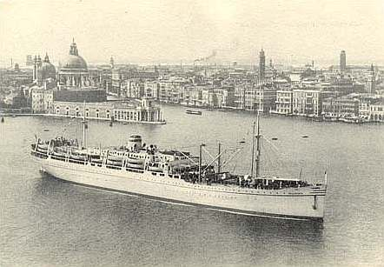
This is an official Cogedar postcard of Flaminia.
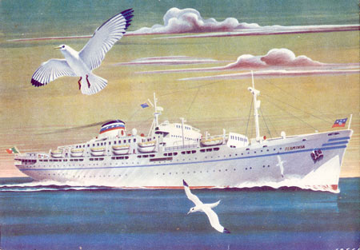
Shown below is an photographic postcard issued by the World Ship Society.


